**Enterprise Data Pipeline (EDPL) Configuration**

1. Create a new schema in MySQL using MySQL Workbench to store the metadata for EDPL (You also choose to store the metadata in other SQL database)

e.g. edpl_dev3

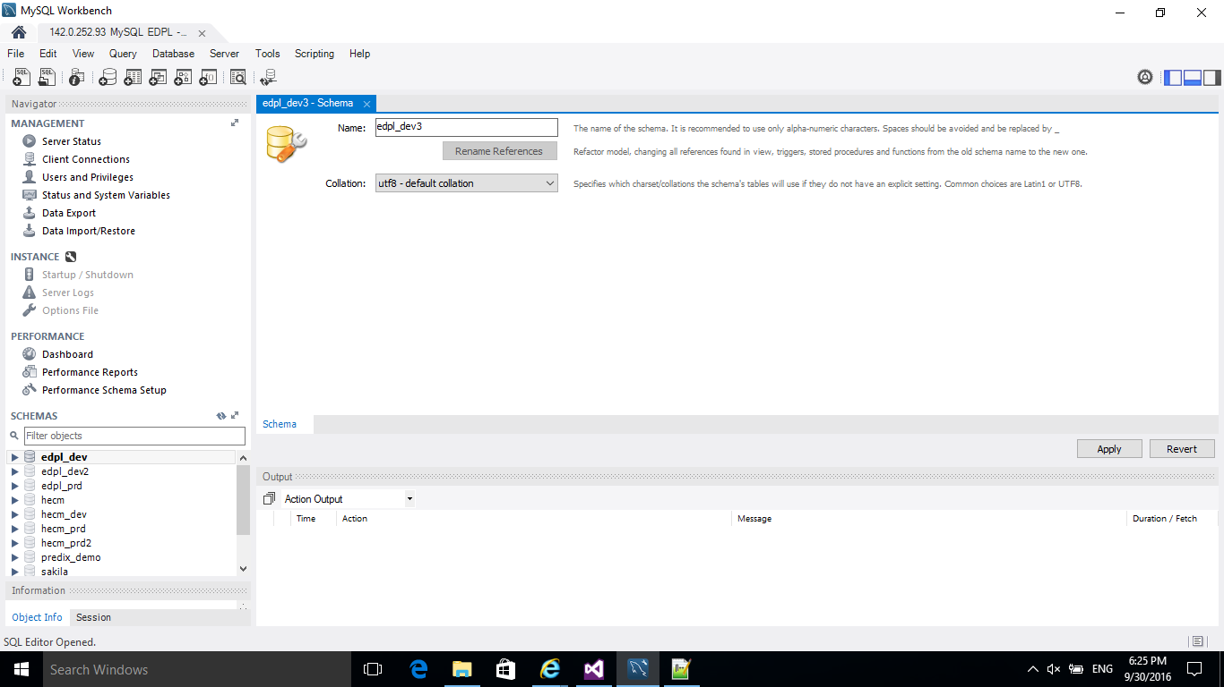

1. Review the SQL script and the click the “**Apply**” button as shown below

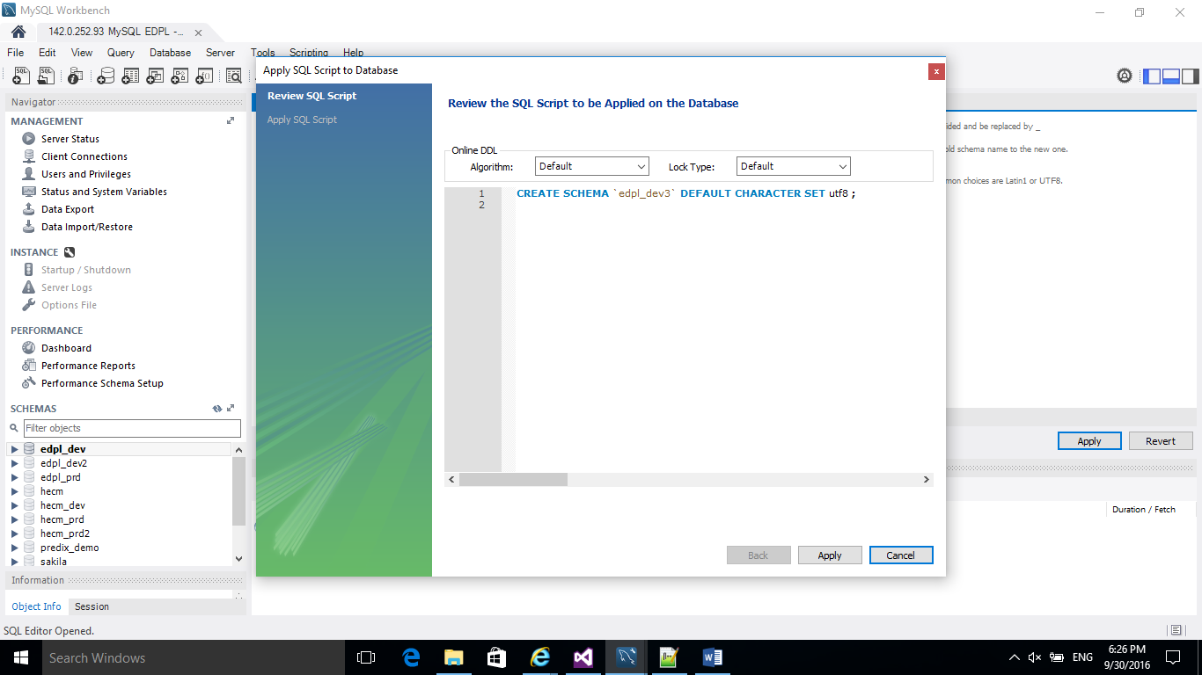

1. Click the “**Finish**” button after the SQL script was successfully applied to the database as shown below

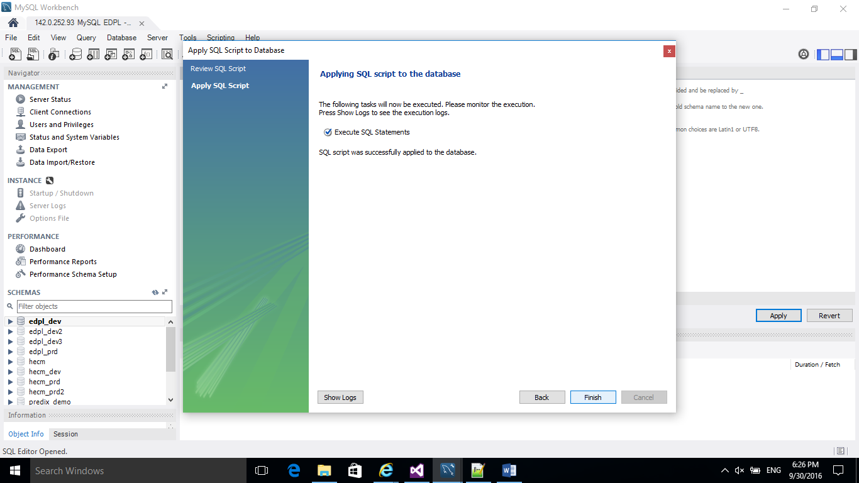

1. Check and verify the new schema “**edpl_dev3**” has been created with no Tables as shown below

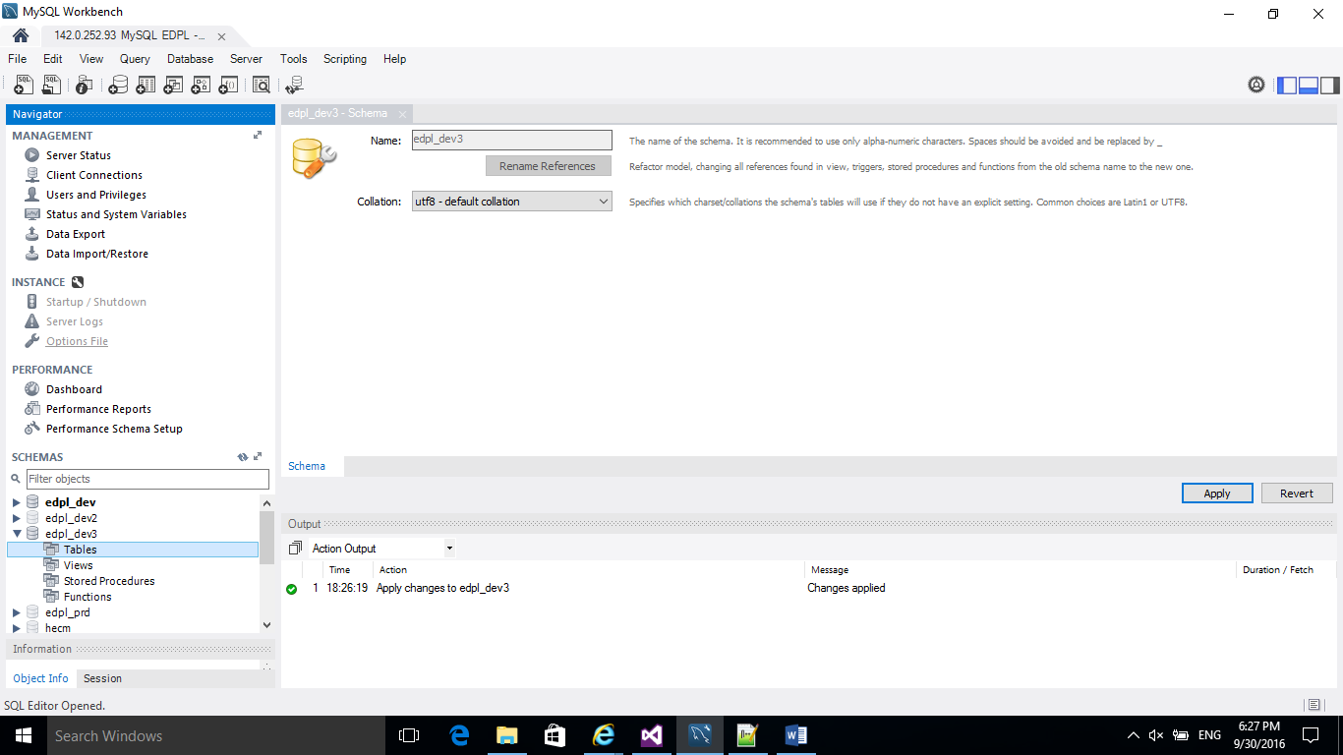

1. Open the MySQL Connection for default schema “**edpl_dev3**” and noted down the Hostname, Port, Username, Password and Default Schema for the connection

e.g.

**Hostname**: 142.0.252.93

**Port**: 3306

**Username**: root

**Password**: PASSWORD (your own password)

**Default Schema**: edpl_dev3

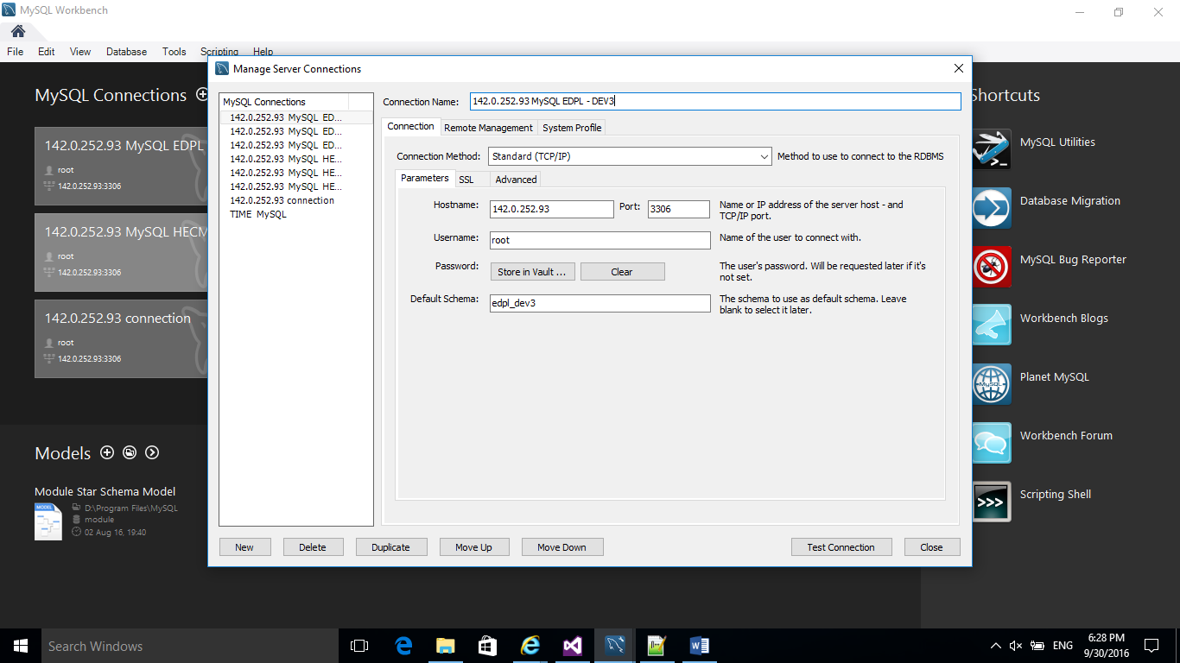

1. Open the “**web.config**” file for the **Enterprise Data Pipeline** solution in Visual Studio 2015. Use the information you noted down in Step 4 and Input the corresponding information to the **DefaultConnection** as shown below.

**server** = 142.0.252.93 (Hostname in Step 4)

**user id** =root (Username in Step 4)

**password** = PASSWORD (Password in Step 4)

**database** = edpl_dev3 (Default Schema in Step 4)

**port** = 3306 (Port in Step 4)

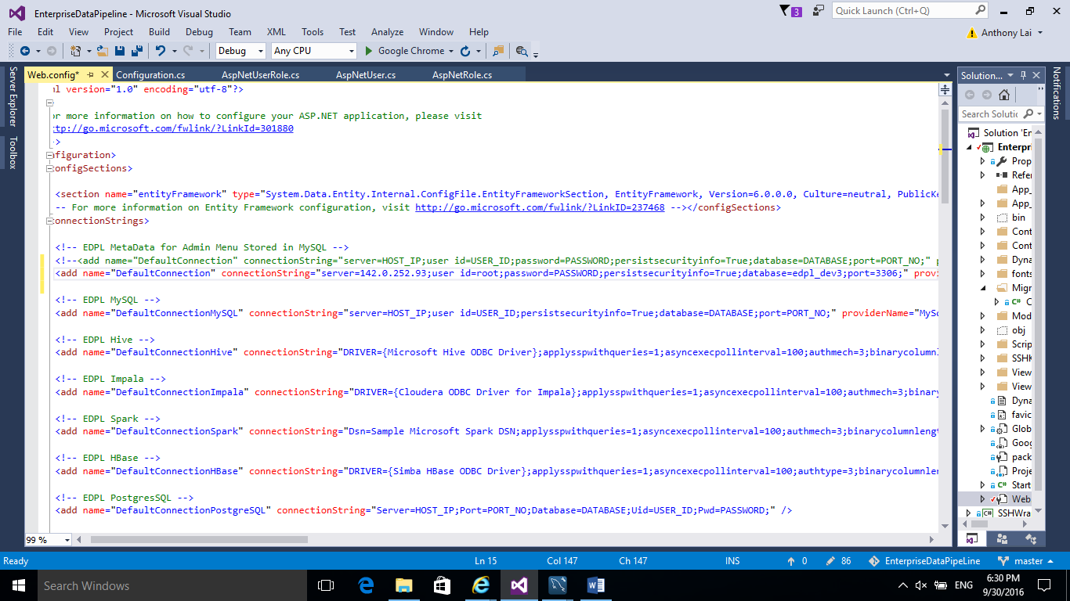

1. In Visual Studio 2015 Solution Explorer, right click the Solution **EnterpriseDataPipeline** and click “**Rebuild Solution**” to rebuild the entire solution as shown below.

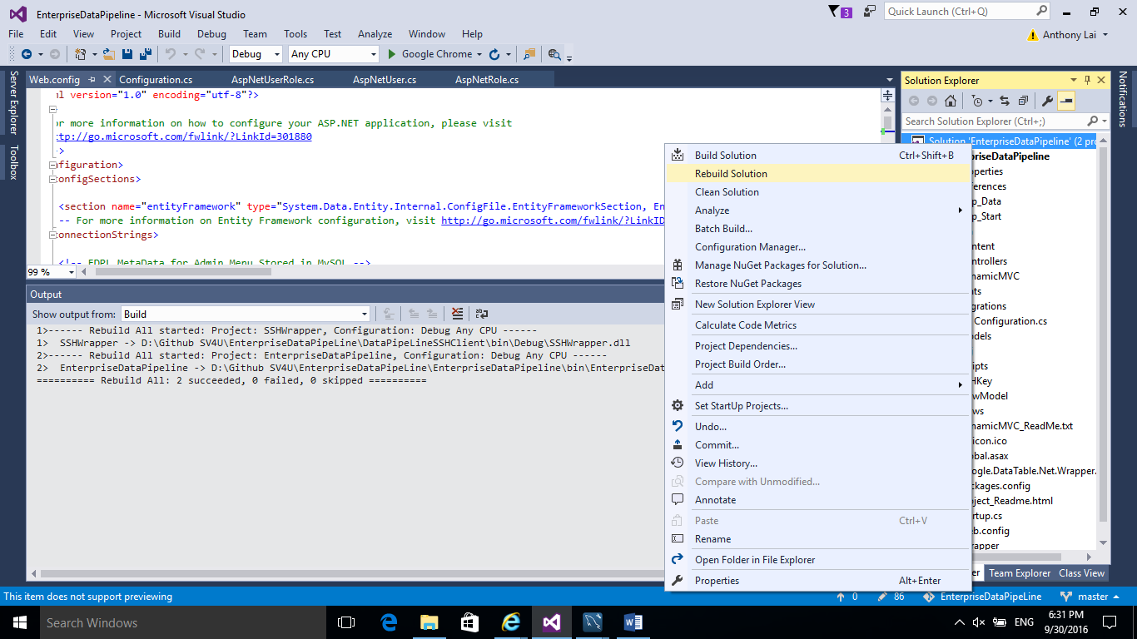

1. Make sure you see no error when rebuild the solution. If you see error, resolve the error first before go to next step.

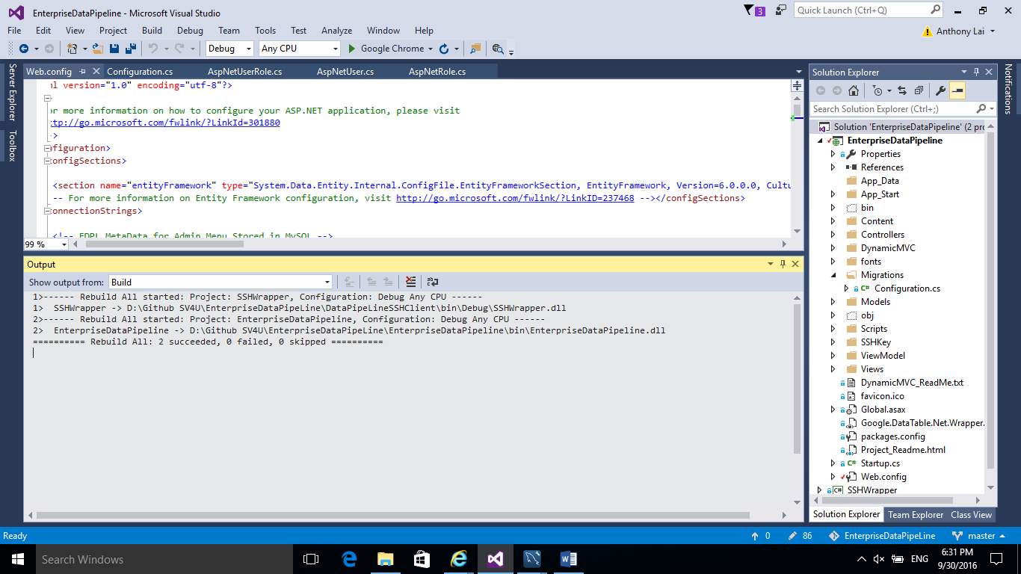

1. Select **Tools** ->**NuGet Package Manager**->**Package Manage Console** as shown below.

(If you don’t see NuGet Package Manager, you need to install it. You can check the link below for installation

<https://visualstudiogallery.msdn.microsoft.com/5d345edc-2e2d-4a9c-b73b-d53956dc458d>)

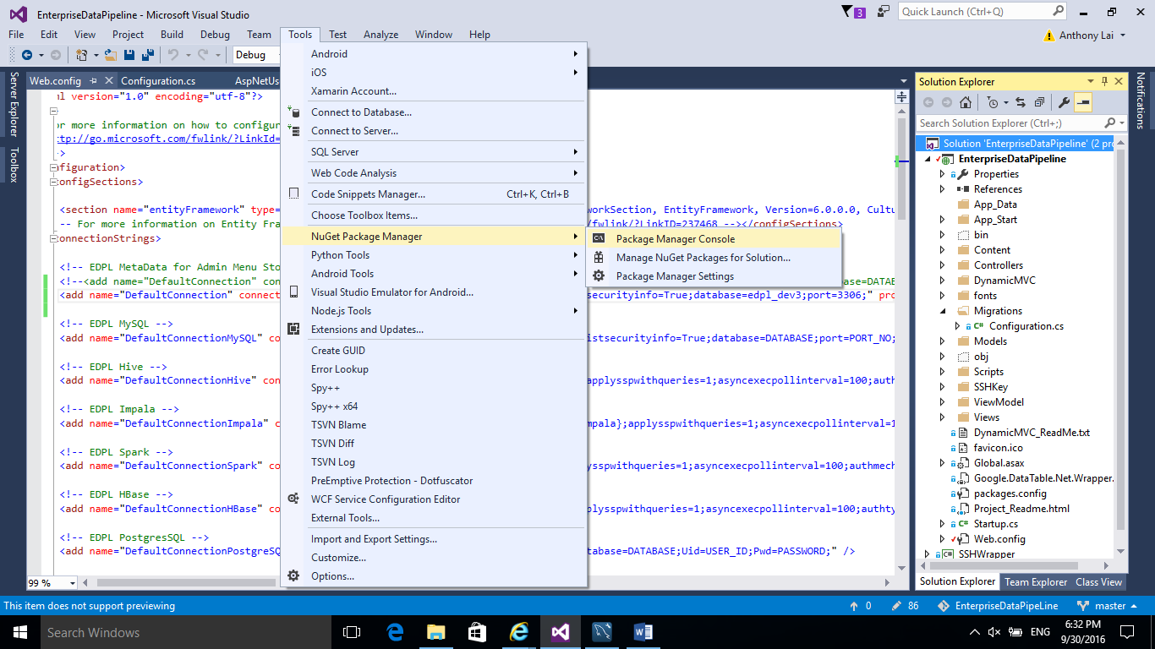

1. After you run **Package Manage Console**, you will see the command console as shown below.

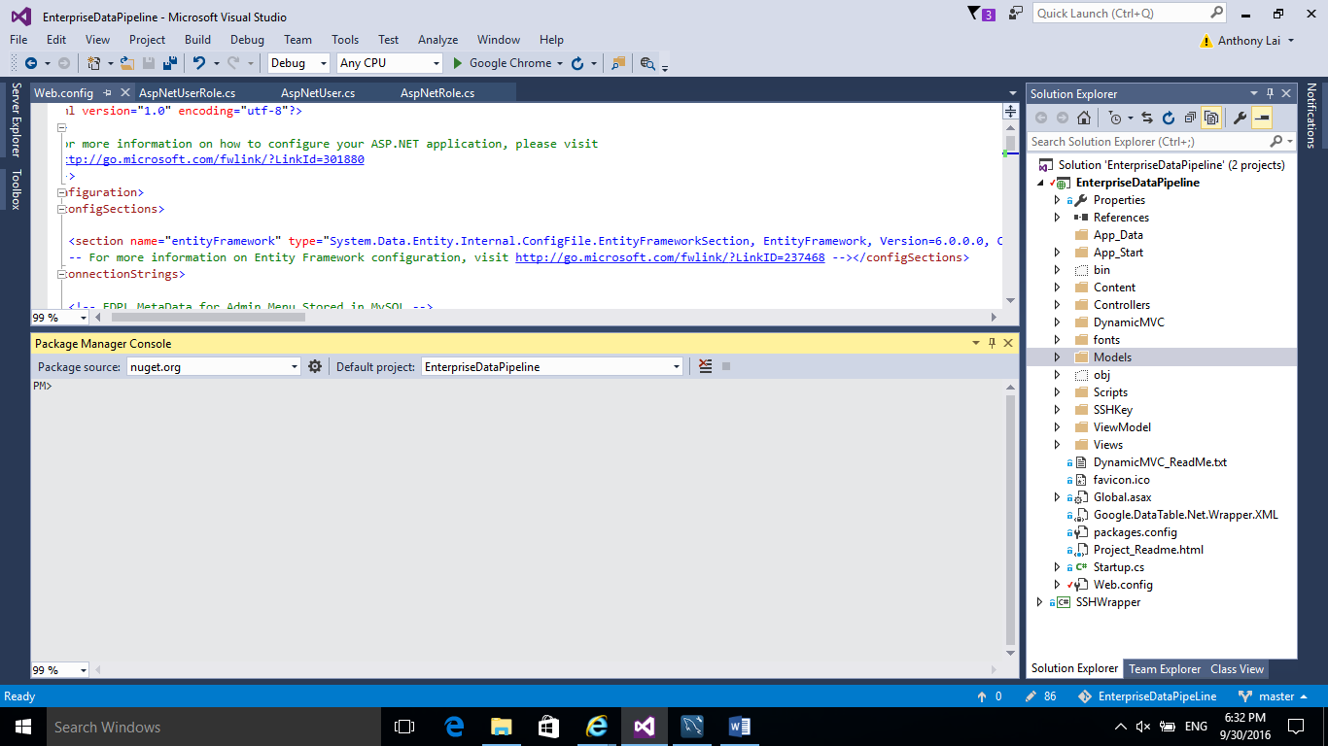

1. In the **Package Manage Console**, run the command “**enable-migrations**”. If the command is run successfully, you will see a new folder called “**Migrations**” created with one file “Configuration.cs” inside the folder

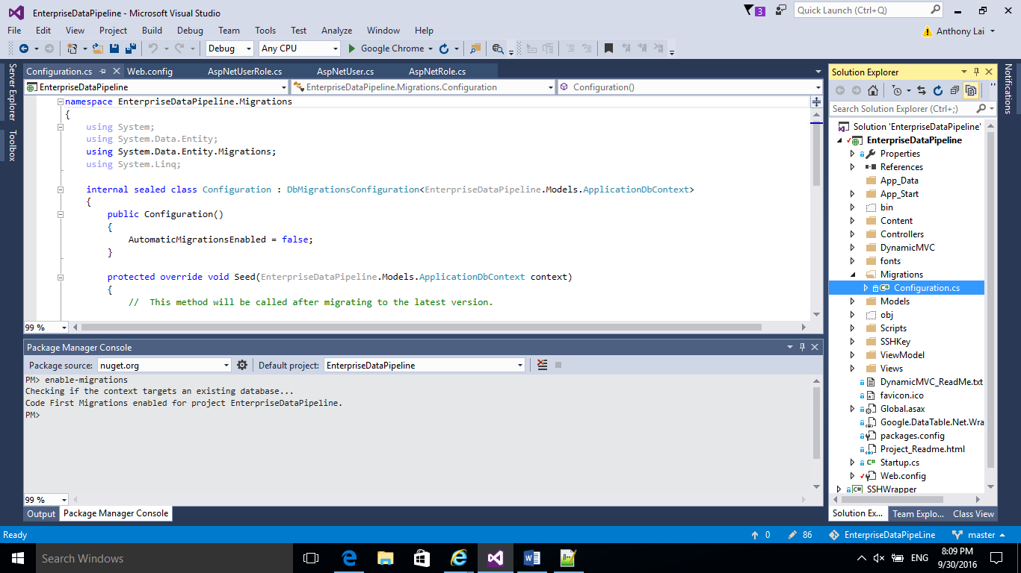

1. In the **Package Manage Console**, run the command “**add-migration InitialCreate**”. If the command is run successfully, you will see a new file “yyyymmddhhmmsss_InitialCreate.cs” has been created under the “**Migrations**” folder

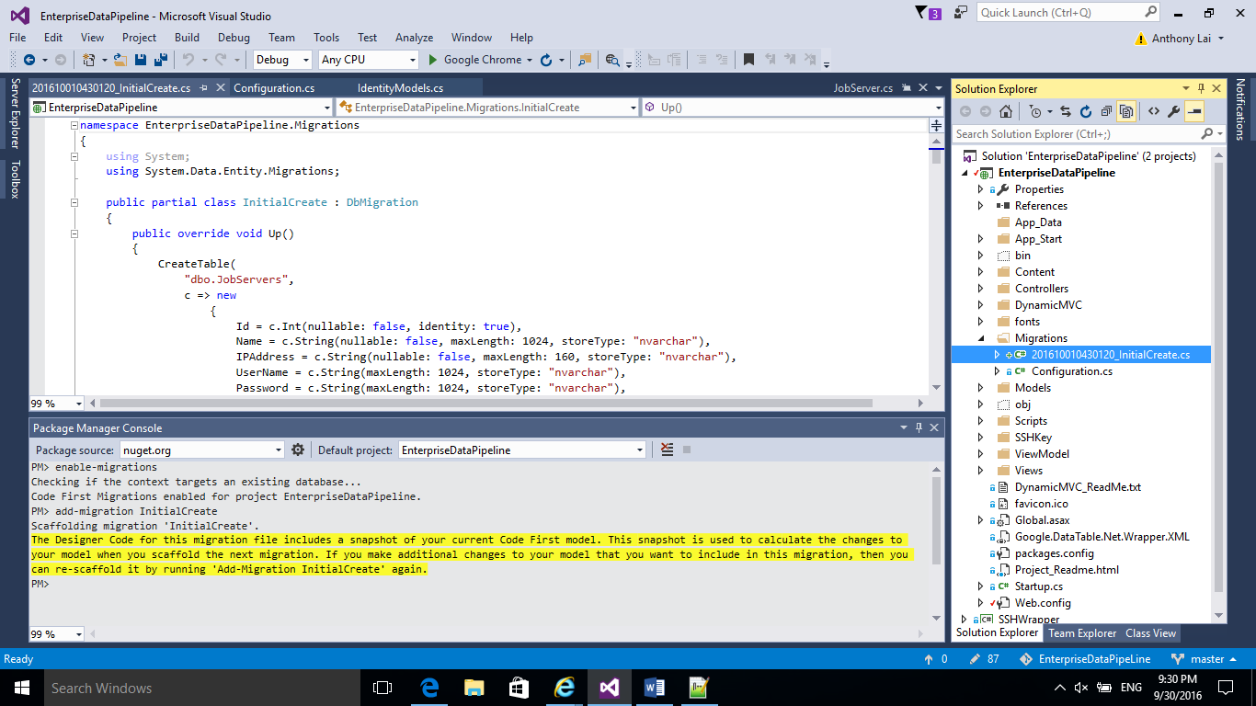

1. In the **Package Manage Console**, run the command “**update-database**”. If the command is run successfully, you will see all the necessary metadata tables will be created in the edpl_dev3 schema in MySQL.

Appendix

